Project Design Phase-II
Data Flow Diagram & User Stories

Date | 31 January 2025
Team ID
Project Name | Book a Doctor – Healthcare Appointment Booking Platform
Maximum Marks | 4 Marks

Data Flow Diagrams:

A Data Flow Diagram (DFD) is a traditional visual representation of the information flows within a system. A neat and clear DFD can depict the right amount of the system requirement graphically. It shows how data enters and leaves the system, what changes the information, and where data is stored.

Example: (Simplified)  Flow  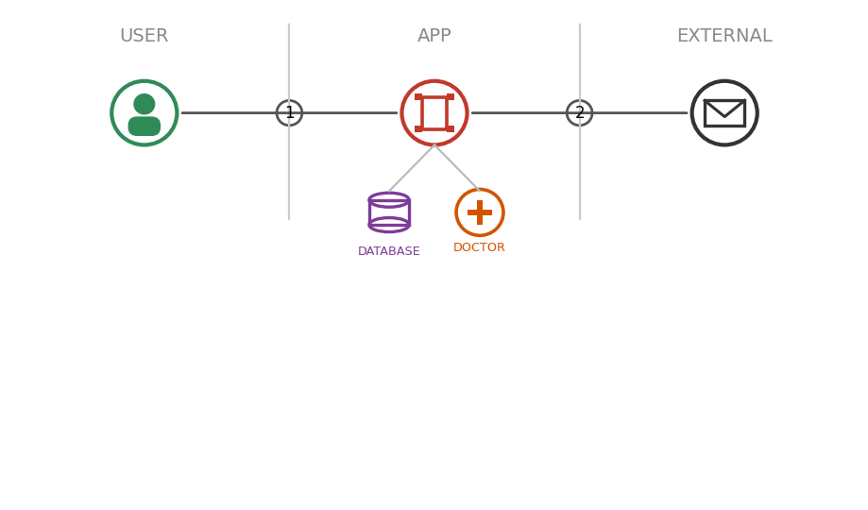  1. Patient registers / logs into the Book a Doctor app.  2. Patient browses doctors and selects an available appointment slot.  3. App checks the database for slot availability and saves the booking request.  4. Doctor reviews the request and approves or rejects it in the app.  5. A confirmation / status notification is sent back to the patient. | 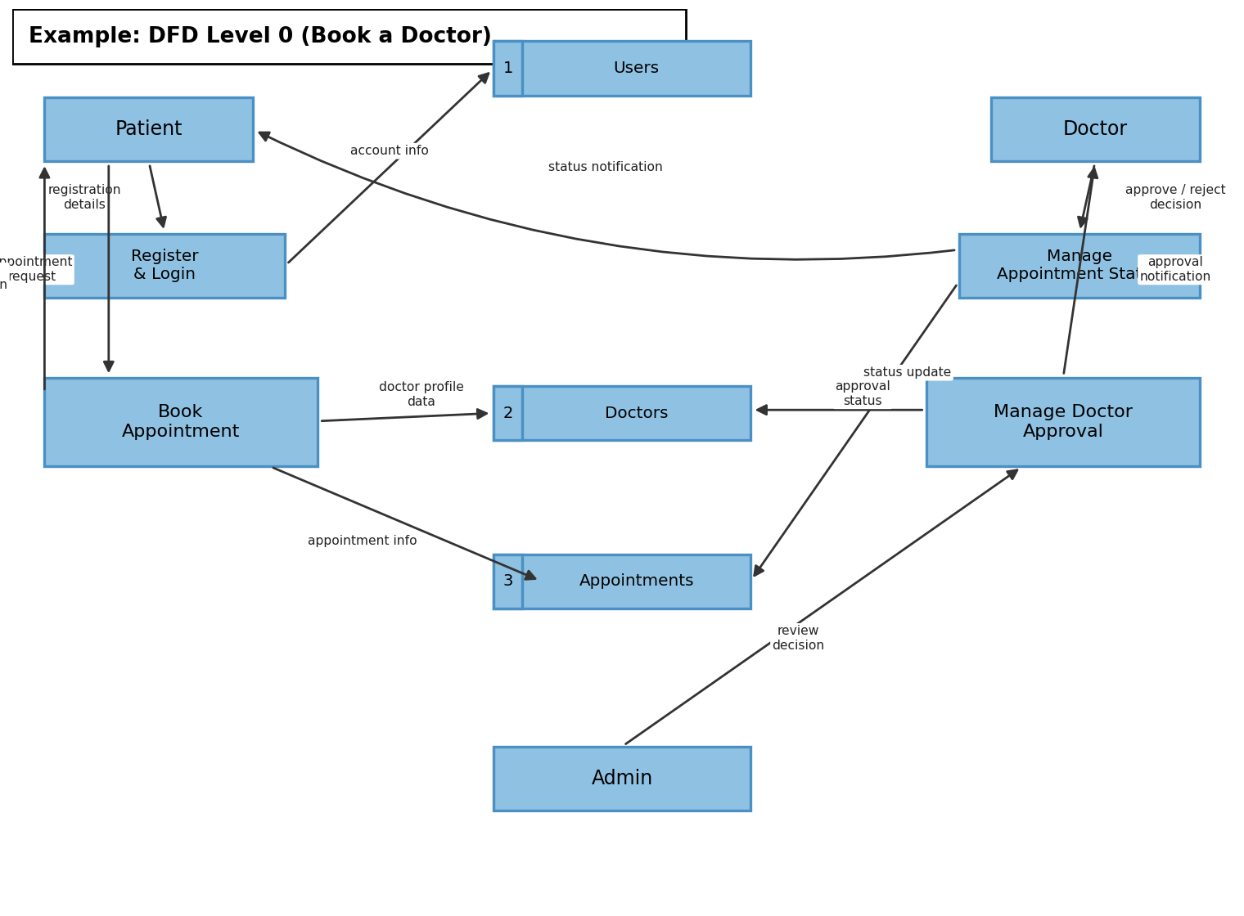

User Stories

Use the below template to list all the user stories for the product.

User Type | Functional Requirement (Epic) | User Story Number | User Story / Task | Acceptance Criteria | Priority | Release
Customer  (Patient) | Registration | USN-1 | As a patient, I can register by entering my name, email, password, and confirming my password. | I can access my account / dashboard after registering. | High | Sprint-1
 |  | USN-2 | As a patient, I will receive a confirmation email once I have registered. | I receive a confirmation email and can log in immediately. | High | Sprint-1
 |  | USN-3 | As a patient, I can register through Google instead of a manual form. | I can register and access the dashboard using Google login. | Low | Sprint-2
 | Login | USN-4 | As a patient, I can log into the application using my email and password. | I am redirected to my dashboard on successful login. | High | Sprint-1
 | Doctor Search & Booking | USN-5 | As a patient, I can browse a list of doctors filtered by specialisation. | I see only approved doctors matching the chosen specialisation. | High | Sprint-1
 |  | USN-6 | As a patient, I can view a doctor's profile including fees, experience, and available timings. | The full profile is displayed before I choose to book. | High | Sprint-1
 |  | USN-7 | As a patient, I can book an appointment by selecting an available date and time. | The appointment is created with status “pending”. | High | Sprint-2
 |  | USN-8 | As a patient, I can upload a medical document while booking an appointment. | The uploaded document is attached to my appointment record. | Medium | Sprint-2
 | Appointments & Notifications | USN-9 | As a patient, I can view the status of all my past and upcoming appointments. | I see each appointment's status: pending, approved, rejected, or completed. | High | Sprint-2
 |  | USN-10 | As a patient, I can cancel an appointment that is still pending. | The cancelled appointment is removed from my active list. | Medium | Sprint-2
 |  | USN-11 | As a patient, I receive a notification whenever my appointment status changes. | A notification appears in-app describing the new status. | High | Sprint-2
 | Doctor Application | USN-12 | As a patient, I can apply to become a doctor on the platform. | My application is submitted with status “pending” for admin review. | Low | Sprint-3
Doctor | Profile Management | USN-13 | As a doctor, I can update my profile details including fees, timings, and specialisation. | My updated profile is immediately visible to patients. | Medium | Sprint-2
 | Appointment Management | USN-14 | As a doctor, I can view all appointment requests booked with me. | I see a complete list of my appointments with patient details. | High | Sprint-2
 |  | USN-15 | As a doctor, I can approve or reject a pending appointment request. | The patient is notified of my decision immediately. | High | Sprint-2
 |  | USN-16 | As a doctor, I can mark a completed consultation as “completed”. | The appointment status updates and appears in the patient's history. | Medium | Sprint-3
Administrator | User & Doctor Management | USN-17 | As an admin, I can view a list of all registered patients. | The full patient list is displayed with key details. | Medium | Sprint-1
 |  | USN-18 | As an admin, I can view all doctor applications and their status. | I see pending, approved, and rejected applications in one place. | High | Sprint-1
 |  | USN-19 | As an admin, I can approve or reject a doctor application. | The applicant is notified and their account access updates accordingly. | High | Sprint-1
 |  | USN-20 | As an admin, I can create a doctor account directly with login credentials. | The new doctor account is created and auto-approved. | Low | Sprint-3
 |  | USN-21 | As an admin, I can remove a doctor or patient account from the platform. | The account and its related records are deleted. | Medium | Sprint-3
 | Oversight | USN-22 | As an admin, I can view all appointments booked across the platform. | The complete appointments list is visible with statuses. | Medium | Sprint-2

